Question1
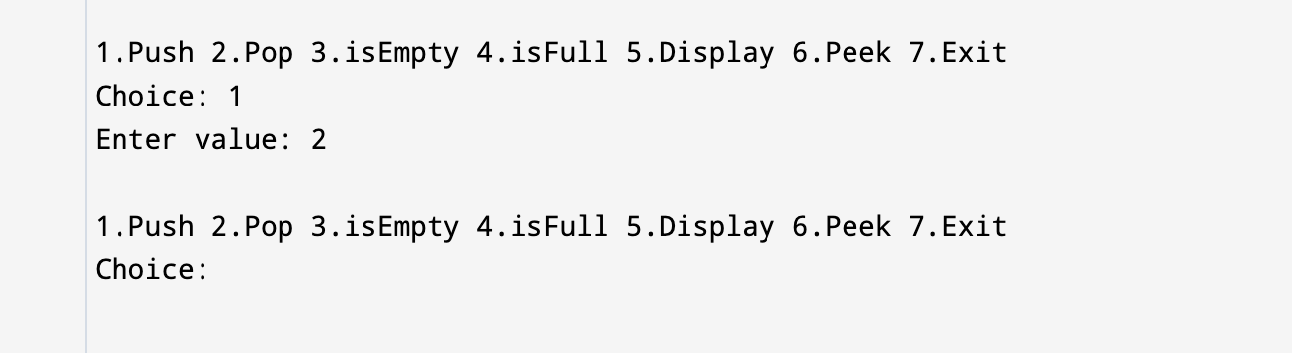

Question 2
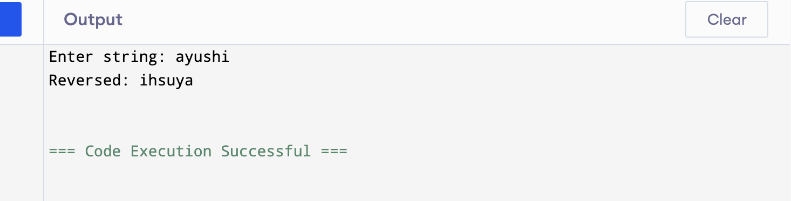

Question 3
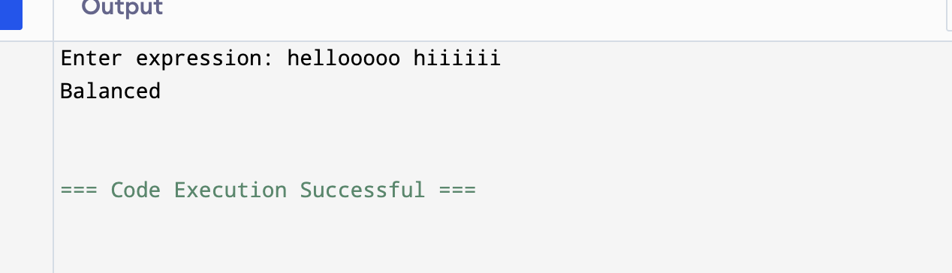

Question 4:
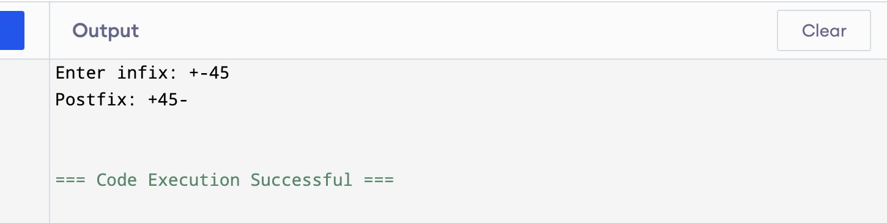

Question 5:l
